**Visualizing Population Distribution**

**by Gender Using a Bar Chart**

Name: **Gajal Sharma**

College: **Poornima University**

**Internship: Prodigy InfoTech**

**Data Science Intern**

**Date: 18 July 2025**

**Introduction**

*The purpose of this project is to visualize population distribution using Python programming and data visualization tools.*

*As part of my internship at Prodigy Infotech, I was assigned the task of creating a bar chart or histogram to represent either a categorical or continuous variable. I chose to work with gender-wise population distribution, which is a categorical variable.*

*Hence, a bar chart was the most suitable visualization method. The goal of this task was to improve data representation skills using Python libraries such as Matplotlib.*

**Objective**

*The objective of this project is to create a bar chart using Python to visually represent the gender-wise population distribution across different countries.*

*This helps in understanding how categorical data like gender can be compared using data visualization techniques.*

**Tools Used**

*• Python 3*

*• Google Colab*

*• Microsoft Word*

**Sample Dataset**

|  |  |  |
| --- | --- | --- |
| Country | Male population  (Millions) | Female population  (Millions) |
| India | 700 | 660 |
| USA | 160 | 165 |
| Brazil | 105 | 110 |
| Nigeria | 110 | 108 |
| China | 720 | 680 |

**Python Code**

Import matplotlib.pyplot as plt

Import numpy as np

# Sample data

Countries = [‘India’, ‘USA’, ‘Brazil’, ‘Nigeria’, ‘China’]

Male_population = [700, 160, 105, 110, 720]

Female_population = [660, 165, 110, 108, 680]

X = np.arange(len(countries))

Width = 0.35

# Plotting the bar chart

Fig, ax = plt.subplots(figsize=(10, 6))

Bars1 = ax.bar(x – width/2, male_population, width, label=’Male’, color=’skyblue’)

Bars2 = ax.bar(x + width/2, female_population, width, label=’Female’, color=’lightpink’)

# Adding labels and title

Ax.set_ylabel(‘Population (in millions)’)

Ax.set_title(‘Population Distribution by Gender’)

Ax.set_xticks(x)

Ax.set_xticklabels(countries)

Ax.legend()

Plt.tight_layout()

Plt.show()

**Output**

*Figure: Bar chart showing male and female population distribution across selected countries.*

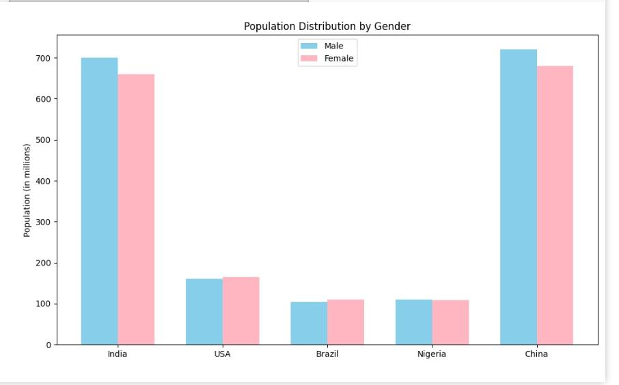

**Conclusion**

*This project helped me understand the importance of choosing the correct type of visualization based on the data type. Since gender is a categorical variable, I used a bar chart to represent the population distribution across five countries.*

*Through this task, I improved my skills in Python and data visualization using Matplotlib. I also understood how simple graphical representations can reveal meaningful patterns in real-world data.*

*This was my first task as a Data Science Intern at Prodigy Infotech, and I look forward to learning more through upcoming assignments.*